May 2020 | Mt. Adnah Cemetery | 315) 592-7338
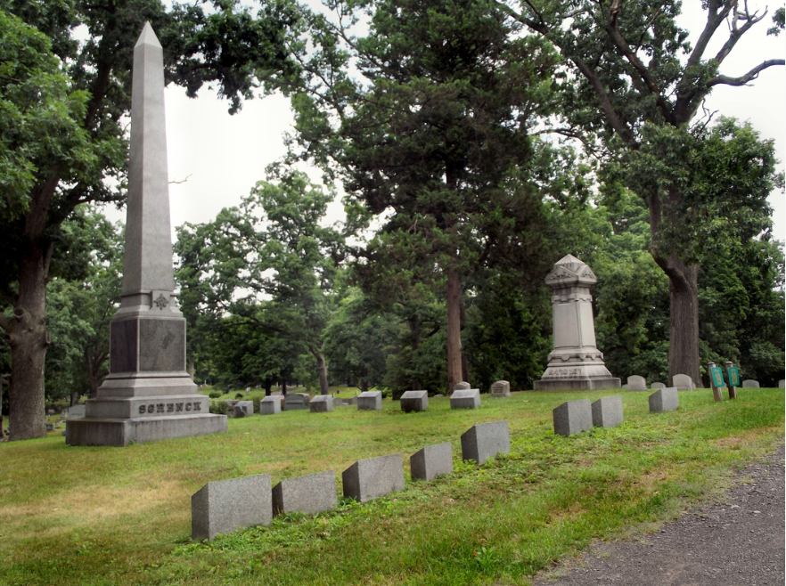
Spring 2020
MT. ADNAH CEMETERY ASSOCIATION
Lot Owners’ Annual Meeting has been postponed until further notice. If you have any questions or concerns, please call 315 592-7338

Like us on Facebook to stay informed of all the upcoming events at Mt. Adnah.

VETERANS’ HONOR ROLL
We at Mt. Adnah Cemetery hope you all are coping well during this trying time. Covid-19 has profoundly changed our lives forever. Routines, workplace and our lifestyles have totally been turned upside down. Even how we at Mt. Adnah Cemetery conduct burials has changed. Safety for all is especially important during this difficult time. Unfortunately, we have currently postponed our annual Chicken BBQ and Barn Sale. This is truly a financial hardship as these fundraiser are needed in order to meet the financial responsibilities of running this historical cemetery.
In May, we have a roll of honor board at the cemetery entrance. Family and friends of military personnel can remember the sacrifices of their loved ones. Whether living or deceased you can put their names on the board for $5.00 each. See attached donation sheet provided. This Veterans’ Honor Roll will be viewable from Memorial Day to July 4th. It is due to the bravery and sacrifices of our Veterans that we are the land of the free. Know all donations go towards the maintenance and upkeep of the cemetery unless otherwise specified. We would like to thank you in advance for your loyal and much needed donations. Please remember all donations are tax deductible.

2
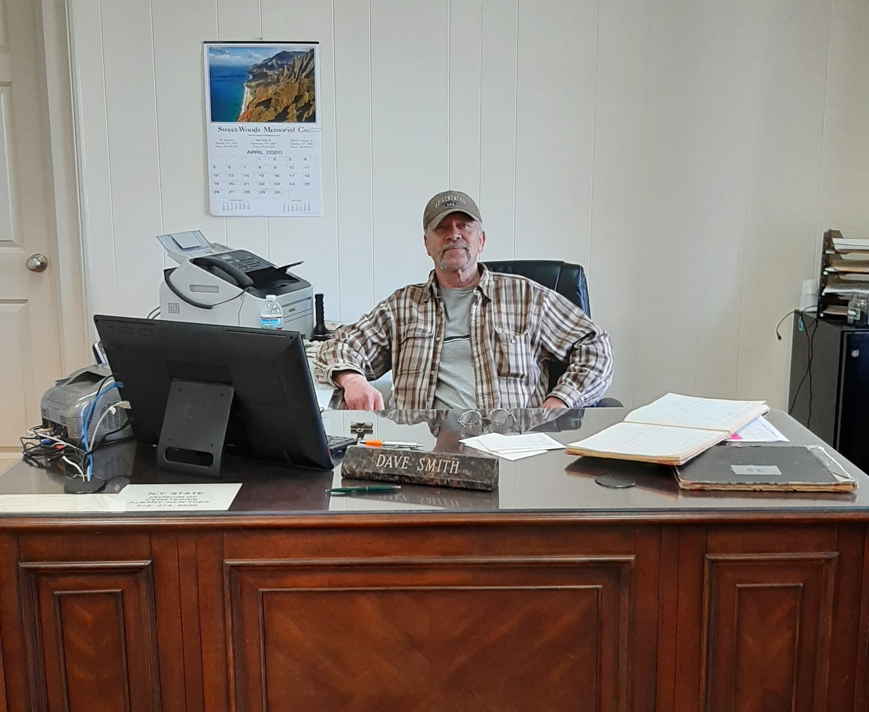 | Message from Dave Smith, Our Superintendent
It was a wet and windy fall and winter season. Our crew has been working diligently raking and picking up branches. Many beautiful trees make for many fall leaves. As always, our goal is to have the cemetery in tip top shape by Memorial Day!! Just a reminder, if you need your stone cleaned or a shrub removed just call 315 592-7338 and I will be able to give you a quote.
“What we have once enjoyed deeply we can never lose. All that we love deeply becomes a part of us.” Helen Keller
 | Christmas Gift Basket Fundraiser Update
Our 2019 Christmas Gift Basket Fundraiser was again a great success. This would not have been possible without the support of Mimi's, Cliff Markets, Lakeview Lanes and the numerous businesses that donated items and their own gift cards for the baskets. The generosity of both the local shops and the community is very heart warming. The winners were drawn at the Tree Lighting Ceremony December 11, 2019, while standing around this amazing beautifully lit tree, provided by Leonard's Farms. We have to say, it was the coldest and windiest night ever!! It is our HOPE that we will see you all again in December this year....and some of us are already praying for 50-degree weather.
Listed below was the winners:
JOHN KNOSP # 1 GIFT CARD BASKET
STACY NICHOLS # 2----CHAMPAGNE & VISA CARD
ANTHONY BOGAWITCH # 3
DON AND SUE RYAN # 4 WINE BASKET
MARY BONNEY # 5 TAILGATE SOFT COOLER TOTE
CLIFF VAN HORN # 6 BURKES TOOL BUCKET
We have two very dedicated Board Members that are stepping down, Rosemary Scott & Henry Hudson. In life there are no sure bets, except that there are people like you who rise to the occasion and make the world a better place. Rosemary & Henry both have worked diligently in the running of this cemetery in various positions and roles for over 15 years each. It is people like this that truly make a difference in our world. We cannot thank them enough for all their love, dedication and service to Mt. Adnah Cemetery! So, Rosemary & Henry we thank you and will miss you!

In life, there are no sure bets, except that people like you will rise to the occasion and make the world a better place.
2
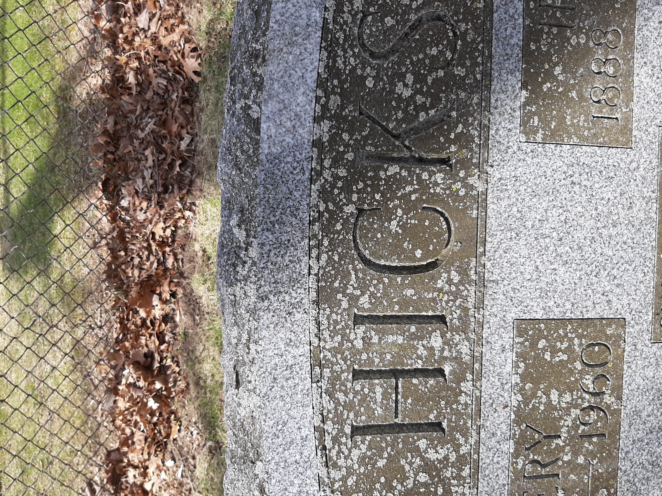  One of the main benefits of choosing burial is that it provides a permanent gravesite that loved ones can visit. For many people, having an allotted space at a cemetery where they can physically go helps with their grieving process. Visiting the grave at the cemetery is considered by some to be a sacred event and allows them to feel a connection to their loved one during their visit. Call the Cemetery office for pricing. 315-592-7338. |  | MAINTAINING A HEADSTONE  A headstone should be cleaned & maintained. Since many of you do not live in the area, we want you to know that you can get a free quote to have your headstone cleaned. Call the cemetery house, 315-592-7338 & Dave Smith, cemetery superintendent will be glad to work with you on a quote.  Also, if you need any bushes or shrubs trimmed or removed, Dave Smith is the person to call.
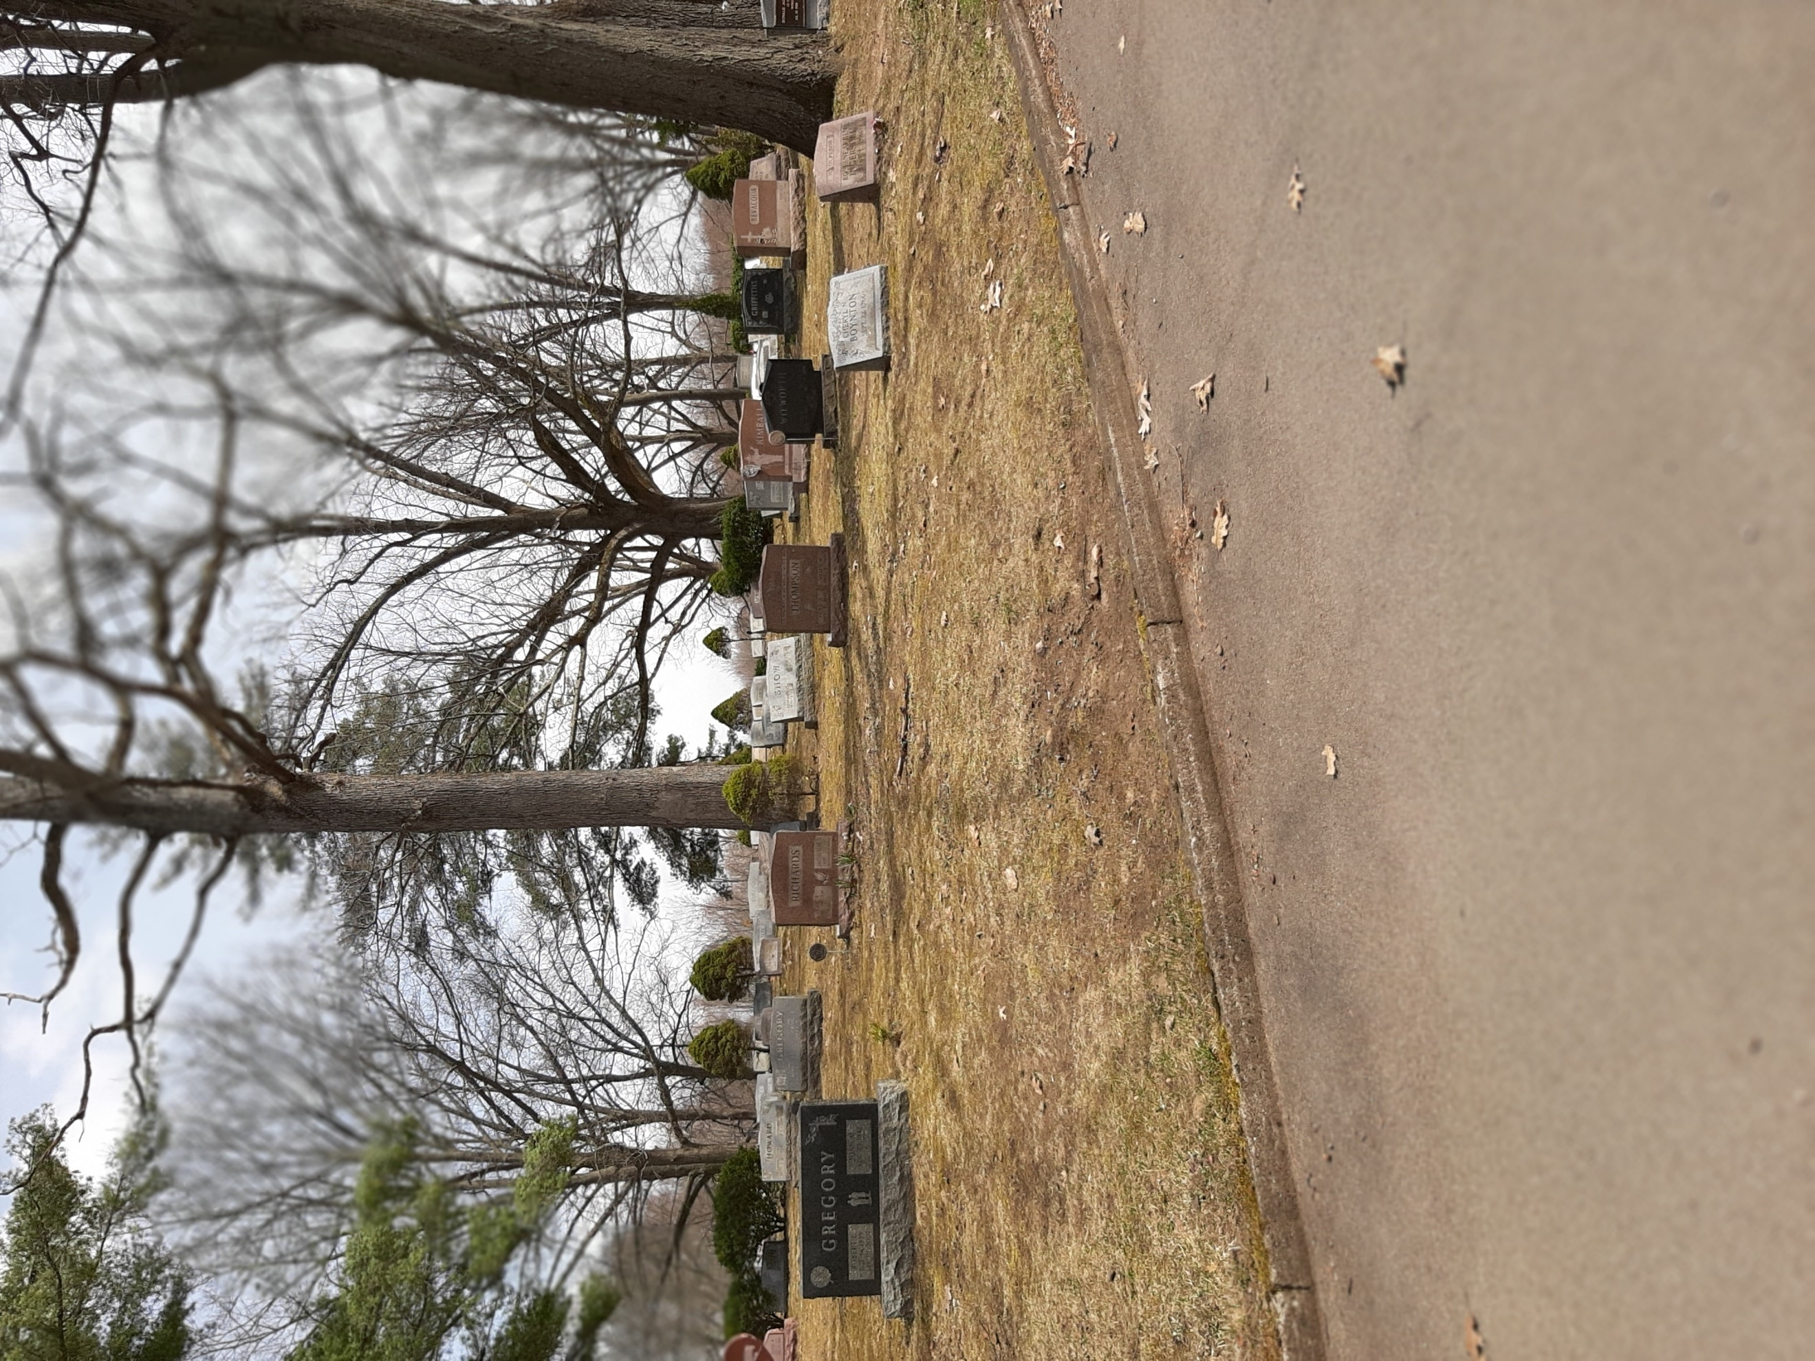

GRAVE SITES AVAILABLE
Mt. Adnah Cemetery
Paul Foster
Bill Wood
Robert Burleigh
Beth Knight
Kurt Brown
Beth Greer
Kyle Gerth

DID YOU KNOW???

The establishment of Mt. Adnah was a direct response to the problem of a rapidly growing community with no truly permanent resting place for its dead. Nineteenth Century histories note a sequence of burial sites near the Village of Fulton, with removals made from one site to the next, as property was needed for housing. The last such removal was made in 1875 with the remains of the old cemetery at Rochester and Seventh Street re-interred in Mt. Adnah.

It is the burial place for many of Fulton's most important citizens, several whom played an important role in the early development of the city and the surrounding area.

****If you are interested in additional information on the History of Mount Adnah Cemetery we have a wonderful overview of the cemetery for $10.00 available for purchase at the cemetery house office, which was built in 1866!! For you who are out of state and would like one please mail a check for $18.50 to cover shipping expenses along with your name and shipping address.

Mt. Adnah Board of Directors

You can also research articles or find “filler” articles by accessing the World Wide Web. You can write about a variety of topics, but try to keep your articles short. Much of the content you put in your newsletter can also be used for your Web site. Microsoft Word offers a simple way to convert your newsletter to a Web publication. So, when you’re finished writing your newsletter, convert it to a Web site and post it.
 | We are pleased to welcome 3 new Board Members. Beth Knight, Kurt Brown and Beth Greer. We thank you for your commitment to the cemetery and community. All of us are excited as we look forward to having a long successful journey maintaining and preserving this historical cemetery!
Mt. Adnah Cemetery Association is required by the State to put 20% of all sales into a permanent perpetual care fund. All monies in this fund are invested and insured by the Federal Government as ordered by the Mt. Adnah Board. The Mt. Adnah Association does not have access to this money
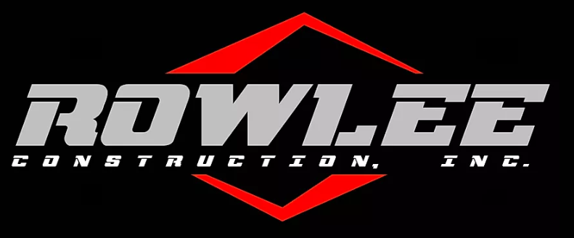
“Carry out a random act of kindness, with no expectation of reward, safe in the knowledge that one day someone might do the same for you.” ~PRINCESS DIANA
Family Owned & Operated serving CNY & the NE Since 1969

A huge thank you goes out to Rowlee Construction for once again donating their staff and construction equipment all day May 16^{th.} They removed the massive piles of leaves that have been gathered up all spring. It was a huge undertaking and would be a financial hardship if it wasn’t for their generous support and commitment to the cemetery and to our community. It is with grateful hearts that we thank Rowlee Construction and their staff for all their hard work!!
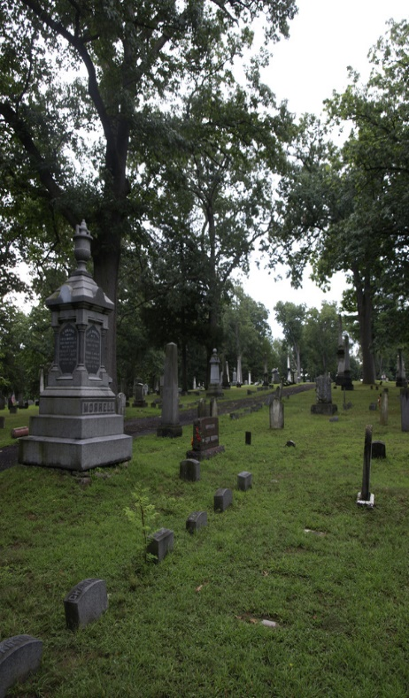tt
Mt. Adnah Cemetery
[Company address]
One of the main benefits of choosing burial is that it provides a permanent gravesite or mausoleum that loved ones can visit when needed. For many people, having an allotted space at a cemetery where they can physically go to visit their loved one helps with their grieving process. Visiting the grave at the cemetery is considered by some to be a sacred event and allows them to feel a connection to their loved one during their visit. If you need assistance in this process, please call the cemetery at 315 592 7338 and we would be happy to go over all options.
[Recipient Name]
[Street address]
[Address 2]
[City, ST ZIP Code]

